**Value of QA engineers in software development.**

In the fast-paced world of making software, people often wonder if certain jobs in the team are needed. I recently heard a question - "Why hire a QA engineer when programmers can handle everything, including testing, for your website?" This question shows a common misunderstanding in the industry – thinking that QA engineer tasks can be done by others, which might save money.

While it might seem like a good idea at first, it forgets how important QA engineers are in making software. In this article, we'll talk about why QA engineers are so important, what they bring to the team, and why you can't just replace them with other team members.

Top of Form

**The Cardinal rule**

In the realm of software testing, there's a fundamental principle that's universally acknowledged: the creators of the code shouldn't be the ones testing it. This axiom holds across software development, operating systems, and testing tools. It's a rule that seasoned professionals in the field are aware of, recognizing its significance and validity.

“Cardinal rule in software development: never have the people who wrote the software quality code test it.”

Having established the cardinal rule that the creators of the code should not be the ones to test it, we can now delve into the reasons behind this principle.

**The developer’s side of the story**

Before delving into the role of a QA engineer, let's understand what developers handle. They're the architects behind your application, constructing it from scratch based on your unique requirements. This task might seem straightforward, but it demands extensive time, skill mastery, and intellectual effort.

However, developers often find themselves bridging the gap between technical complexities and business objectives. This necessitates effective communication with business stakeholders. Hence, you'll likely require an intermediary who can articulate your business goals and challenges, translating them into actionable engineering tasks.

**From a software Quality Assurance perspective**

In software development, it's important to recognize the significance of Software Quality Assurance (QA) engineers. Their job is crucial for making sure that the software works well and meets the needs of users from start to finish. They play a key role in ensuring the quality and functionality of the software as it's being created.

**Purpose of hiring Software Quality Assurance**

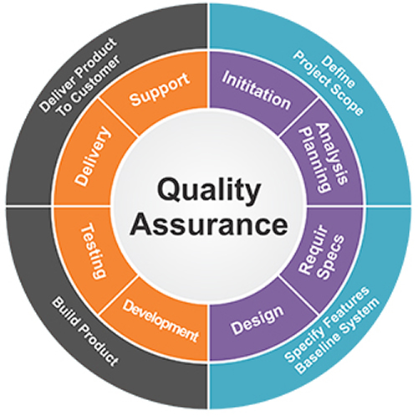

Hiring Software Quality Assurance (QA) engineers brings several benefits to a software development project:

1. **Ensured Quality:** QA engineers ensure that the software meets quality standards and functions as intended, reducing the risk of defects or issues in the final product.
2. **Early Issue Identification:** They identify and address issues or bugs early in the development process, saving time and resources by preventing larger problems down the line.
3. **Improved User Experience:** By understanding user needs and expectations, QA engineers contribute to creating a software product that aligns with user requirements, enhancing the overall user experience.
4. **Objective Evaluation:** Their unbiased perspective allows for objective evaluation of the software's quality, free from the biases that developers may have.
5. **Process Improvement:** QA engineers often implement and improve testing processes, methodologies, and tools, leading to more efficient and effective software development cycles.
6. **Risk Mitigation:** They help mitigate risks associated with software development, ensuring that potential issues are addressed before they impact the product's performance or reliability.

**Values**

In addition to ensuring the quality of software, QA engineers offer unique value. They serve as a connection between developers and end users, understanding user needs to guide development. Early bug detection saves time and resources, and their unbiased perspective enhances product quality. They're not just gatekeepers but vital contributors to software success.

The role of a Software QA engineer goes beyond testing tools. They bridge the gap between developers and users, ensuring the final product meets expectations. By overseeing development, they prevent issues, save resources and enhancing quality. Investing in skilled QA engineers is strategic for software success.

**Conclusions**

Bear in mind that the success of your business software products hinges significantly on the quality and performance of your application, as well as its timely market launch. These factors are greatly facilitated by the expertise of the software QA staff. In other words, hiring the right people for the right job, and you should be fine."